Submission on Shoalhaven GMS 2019-2041 Discussion Paper
The Forum Committee has previously expressed to Council the concerns held by the Berry community about lack of amenity and infrastructure planning for major developments.
The lack of planning is evident in the development at Huntingdale, which will contain around 300 dwellings when completed. The current Planning Proposal will add another 150 dwellings and the total of 450 new dwellings compares to around 480 existing dwellings in the town (from North St. to the railway in the south, and from the Highway in the west to Pullman St in the east - excluding the Arbour and Grange developments).
Council’s current GMS identifies Lots 762 & 763 to the west of Princes Highway for Long Term Investigation (15+ years) for potential future development. At the Forum meeting on 12 October 2017, attended by 86 residents, there was an overwhelming vote to reject the Planning Proposal’s rezoning of Lots 762 & 763, and also part of Lot 764.
At a meeting with senior Council planning staff, it was explained to the Forum Committee delegate that Council would support the Proposal on the condition that the southern boundary would align with the LTI Area identified in GMS V1 and that Council would hold the line at that southern-most boundary for the long term.

Based on this explicit understanding, the Forum Committee was very concerned to discover that Growth Option 1 in the Discussion Paper proposed extending the area available for development of hundreds more dwellings as far south as Schofields Lane (red arrows).

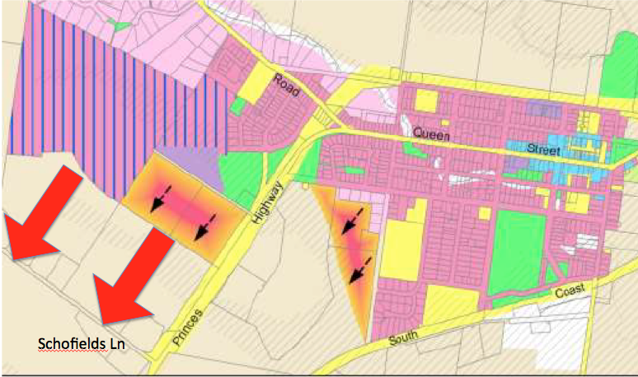

When senior Council staff were asked about the discrepancy between the position communicated at the meeting with the Forum delegate and the GMS paper, the response received was that it was not intended that the GMS contemplate extending the investigation area all the way to Schofields Lane. We believe that is also the Berry community view, as expressed through feedback at the October 2017 Forum meeting.

The request for broad community feedback is supported, but the Forum Committee is concerned that the density and complexity of the Discussion Paper and survey could defeat most residents and that limited numbers expressing concerns about the southern boundary in the survey will be mistakenly interpreted by Council as representative of broad community support for the LTI area to be extended to Schofields Lane.

It is the Forum Committee’s view that Growth Option 1 should be amended to reflect the outcome of discussions between the Committee and Council, so that it can be considered as a viable alternative for the draft GMS when it is prepared next year. If Option 1 is not amended, and is eventually selected for the draft GMS, Council should conduct a rigorous review and be prepared to hold extensive consultations with the Berry community.

Forum Committee
http://berryforum.org.au/

